Applied Methods in Health Services and Outcomes Research

Homework assignment 5: (Propensity score analysis: Stratification, Regression)

Data from a cohort of 514 infants with very low birthweight (<1,600 grams) from 1981-87 were collected at Duke University Medical Center. The project was undertaken to evaluate the association between the exposure of interest of intraventricular hemorrhage (IVH) and the outcome of death (DEAD). Measured potential confounders included birthweight, gestational age, presence of pneumothorax, mode of delivery, single vs. multiple gestation, and whether the birth occurred at Duke or at another hospital with later transfer to Duke.

In this analysis, the primary outcome of interest is death (DEAD). The primary exposure of interest variable is IVH (“1” denoting the presence of the condition). The SAS data set “hw_vlbw” is available in CourseWorks. Variable names and definitions are provided in a table below. SAS code examples are provided in the file “LAB_PS_SAS_CODES.sas”

Objectives: Develop propensity score analyses to examine the association between IVH and mortality.

Practice the analytical skills:
- Apply propensity score (PS) stratification and regression.

Requirements:
- Fit your PS step 1 logistic regression models using exposure of interest (IVH) as the response variable and baseline factors (measured confounders) as the predictors. You fit a simple model without interactions.
- Present table 1 for strata (reporting column percentage by exposure arms). (20 points)
- Present two plots: (1)proportion of patients at each stratum by exposure groups; (2) propensity score distribution by strata and exposure groups. (20 points)
- Fit PS step 2 models for PS-stratification and PS-regression. Present one table 2 including: (1) the unadjusted odds ratio or risk ratio (95%CI) from homework 1, (2) the adjusted odds ratio or risk ratio (95%CI) from the multivariable model from homework 1, (3) the adjusted odds ratio or risk ratio (95%CI) from the PS-matched method, (4) the adjusted odds ratio or risk ratio (95%CI) from the PS-IPTW, (5) the adjusted odds ratio or risk ratio (95%CI) from the PS-stratification, and (6) the adjusted odds ratio or risk ratio (95%CI) from the PS-regression. (20 points, 10 points for PS-stratification estimates, 10 points for PS-regression estimates; see examples)
- Interpret your finding in plain, lay terms for table 1 and table 2. Comments on the pros and cons for multivariable regression and different PS methods. (40 points)
Provide the SAS programing, log files and clear notes as the appendix.

Variables of interest

Variable | Definition
dead | Dead 1= Dead 0=Alive
Ivh2 | Intraventricular hemorrhage 1=Yes 0=No
bwt | Continuous variable Birth weight (g)
gest | Continuous variable Gestational age (weeks)
pneumo | Pneumothorax occurred 1=Yes 0=No
Delivery_new | Mode of delivery 1=C-Section 2=Vaginal 9=Unknown
twin | Multiple gestation
Inout_new | 1=”Born at Duke” 2= “Transport”

Requirement 2 Example: Table 1 from for PS stratification cohort

 | Stratum 1 |  | Stratum 2 |  | Stratum 3 |  | Stratum 4 |  | Stratum 5
 | Surgery No | surgery Yes | Surgery No | surgery Yes | Surgery No | surgery Yes | Surgery No | surgery Yes | Surgery No | surgery Yes
 | N (%) | N (%) | N (%) | N (%) | N (%) | N (%) | N (%) | N (%) | N (%) | N (%)
age_cat2
41-59
60-69
70-79
80-89
race2
White
Black
Other
Unknown
insurance2
Private Insurance
Medicaid/No insured
Medicare
Other/Unknown
income
< $30,000
$30,000 - $35,999
$36,000 - $45,999
$46,000 +
Unknown
BMI_cat
Normal(<25.0)
Overweight(25.0-29.9)
cdcc2
0
>=1
Unknown
stage2
I
II
grade2
Well/Moderate
Poorly
Unknown
facility_location
Eastern
South
Midwest
West
facility_type
Non-Academic program
Academic/Research Program
year_of_diagnosis_cat
1998-2004
2005-2007
2008-2009
2010-2011

Requirement 3 Example:

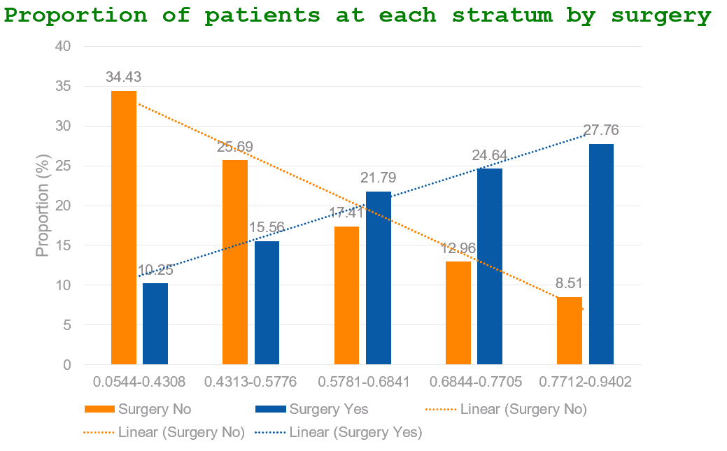

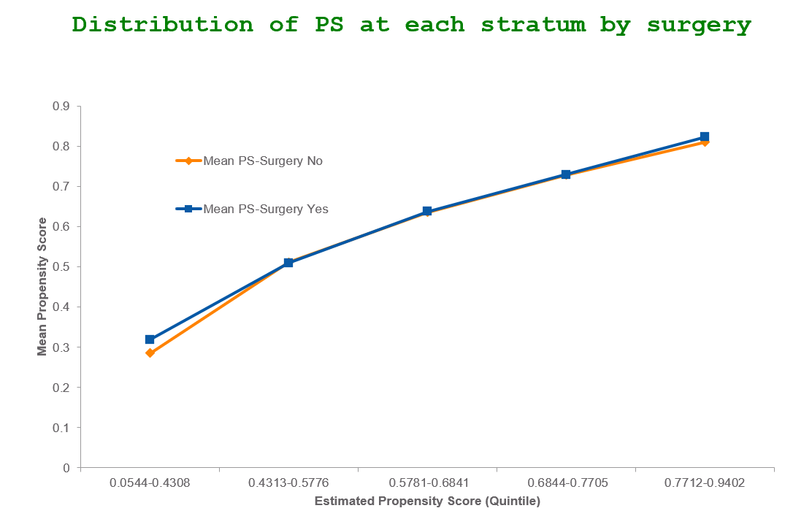
Requirement 4 Example: Table 2 – unadjusted estimate, adjusted estimate from regression modes, adjusted estimate from PS Matched, adjusted estimate from PS IPTW
 |  |  | ORs (95%CI)
 | Dead = 0 | Dead = 1
Surgery
No | 394(76.2) | 123(23.8) | Referent
Yes | 695(90.1) | 76(9.9)
Unadjusted ORs |  |  | 0.35(0.26-0.48)
Adjusted ORs
Multivariable model based on Science |  |  | 0.52 (0.36-0.74)
Multivariable model Purposeful Selection |  |  | 0.50 (0.36-0.71)
PS Matched |  |  | 0.52 (0.35-0.78)
PS IPTW |  |  | 0.54 (0.38-0.76)
PS Stratification |  |  | 0.53 (0.38-0.75)
PS Regression |  |  | 0.54 (0.38-0.75)

